Default Key Values
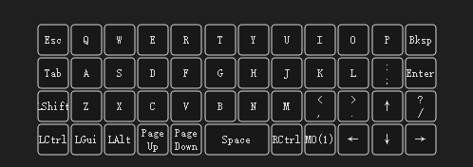

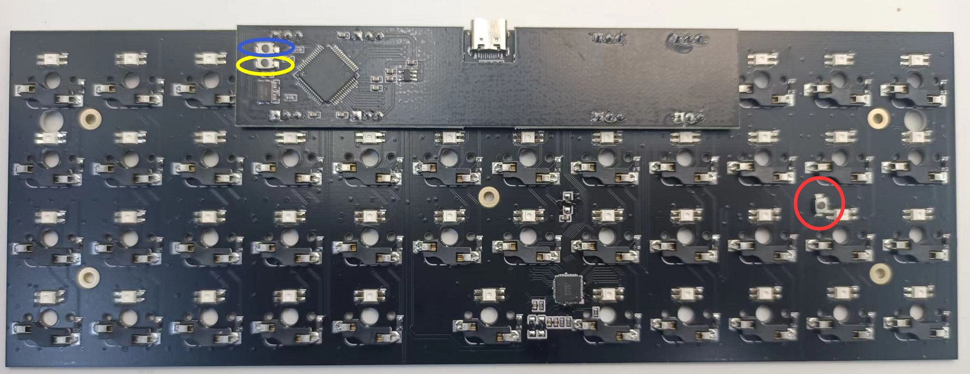
The Red and blue circle is the button to reboot for flashing.
The yellow circle is reset button.
When flashing firmware, to press blue or red button then plug the PCB, you can enter the Boot mode.
Or hold the first key on the left corner to enter Boot mode.

